AI ASSISTANT CODING ASSIGNMENT 4
NAME : SAMPELLY SUHAS
ROLL NO : 2303A51453
BATCH NO : 21

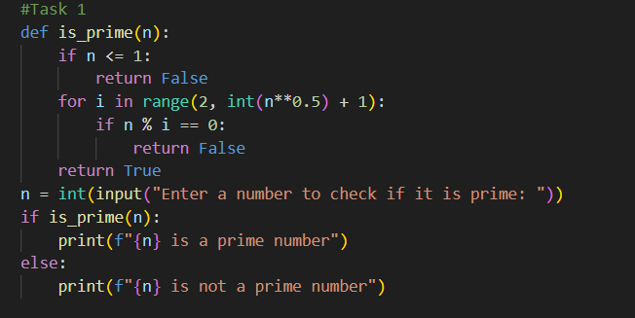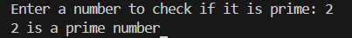
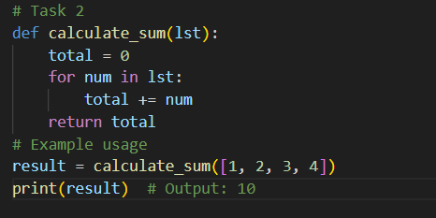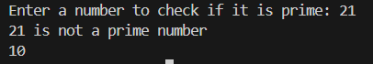
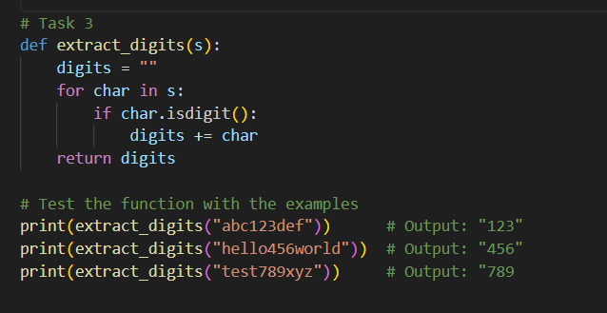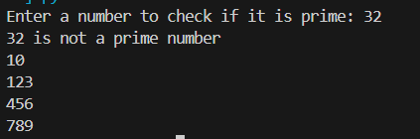
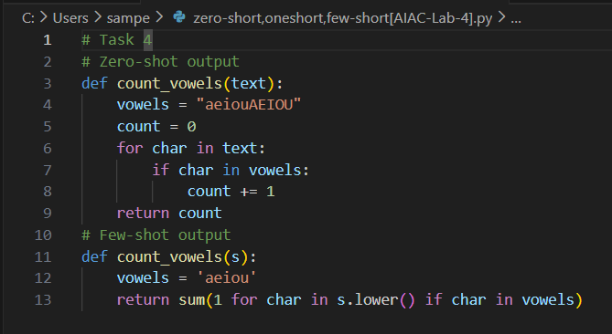
# Output comparision:

Zero-shot Approach | Few-shot Approach
Prompt:  "Write a Python function that counts the number of vowels in a string." | Prompt:  "Write a Python function that counts the number of vowels in a string.  Examples:  1. Input: 'hello', Output: 2 (e, o)  2. Input: 'python', Output: 1 (o)  3. Input: 'education', Output: 5 (e, u, a, i, o)"
Generated Code:  python<br>def count_vowels(text):<br> vowels = "aeiouAEIOU"<br> count = 0<br> for char in text:<br> if char in vowels:<br> count += 1<br> return count<br> | Generated Code:  python<br>def count_vowels(s):<br> vowels = 'aeiou'<br> return sum(1 for char in s.lower() if char in vowels)<br>
Characteristics:  • Basic for-loop approach  • Explicitly includes both uppercase and lowercase vowels  • Straightforward but verbose  • No examples provided | Characteristics:  • Uses Pythonic generator expression  • Converts to lowercase with .lower()  • More concise (single line return)  • Guided by 3 examples

Key Differences & How Examples Helped:
- Code Efficiency: Few-shot produced more concise code using sum() with a generator expression.
- Case Handling: Zero-shot explicitly lists both cases; Few-shot uses .lower() for simplification.
- Readability: Few-shot version is more Pythonic and readable.
- Learning from Examples: The AI recognized from the examples that:
  - Only lowercase vowels needed counting
  - A counting approach was required
  - The output should be a simple integer

